Venn Diagram Application

# User Manual

Group 12

Version 3.0.0

04/15/2020

Table of Contents

1. Introduction 1

2. Working Principles 1

3. Common Usage Scenarios 2

4. How To Get Started 5

5. Using the System 6

5.1 ‘Insert Title’ Feature 6

5.2 ‘Adding entries to the Venn Diagram’ Feature 7

5.3 ‘Dragging’ Feature 8

5.4 ‘Menu Bar’ Feature 8

5.4.1 ‘File’ Tab 8

5.4.1.1 ‘New’ Button 9

5.4.1.2 ‘Save’ Button 9

5.4.1.3 ‘Load’ Button 9

5.4.1.4 ‘Help’ Button 9

5.4.1.5 ‘About Us’ Button 9

5.4.2 ‘Home’ Tab 10

5.4.2.1 ‘Size’ Feature 10

5.4.2.2 ‘Font’ Feature 11

5.4.2.3 ‘Text Style’ Feature 11

5.4.2.4 ‘Text Colour’ Feature 11

5.4.2.5 ‘Text’ Feature 11

5.4.3 ‘Design’ Tab 11

5.4.3.1 ‘Size’ Feature 12

5.4.3.2 ‘Colour’ Feature 12

5.4.3.3 ‘Component Alignment’ Feature 13

5.4.5 Other features and functions 13

Appendix A: Record of Changes 15

List of Figures

Figure 1: Venn Diagram Application FX uses Java jdk 13 and JavaFX 11 1

Figure 2: Eclipse based on Java FX coding 2

Figure 3: Venn Diagram Application Common Usage Scenario 5

Figure 4: Venn Diagram Application Startup Page 6

Figure 5: Venn Diagram Application ‘Insert Title’ 7

Figure 6: Venn Diagram Application new title ‘Basketball v Soccer’ 7

Figure 7: New entry to the Venn Diagram 7

Figure 8: Adding an Entry (1) 8

Figure 9: Adding an Entry (1) 8

Figure 10: ‘Click to add Text’ box 8

Figure 11: ‘Drag’ box 8

Figure 12: Menu Bar 8

Figure 13: File tab 9

Figure 14: Home tab 10

Figure 15: Design tab 11

Figure 16: Present tab 13

Figure 17: Normal Presentation 13

Figure 18: Presentation Evaluation Mode 14

List of Tables

Table 1: Record of changes 15

## Introduction

The Venn Diagram Application is a software tool for maximizing customizability to the user’s desire to view and see the relationship between sets of information/items.

Learning to use this software is easy, however you should read and review this document thoroughly before making use of the software.

The user manual presents an overview of the application’s features and gives step-by-step instructions for completing a variety of tasks.

This User Manual (UM) provides the information necessary for users to effectively use the Venn Diagram Application.

**2. Working Principles**

This software uses Java JDK 13 and JavaFX 11.

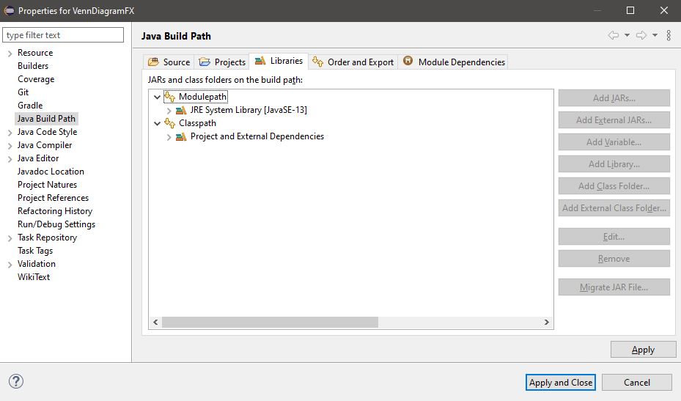

Figure 1: Venn Diagram Application FX uses Java jdk 13 and JavaFX 11

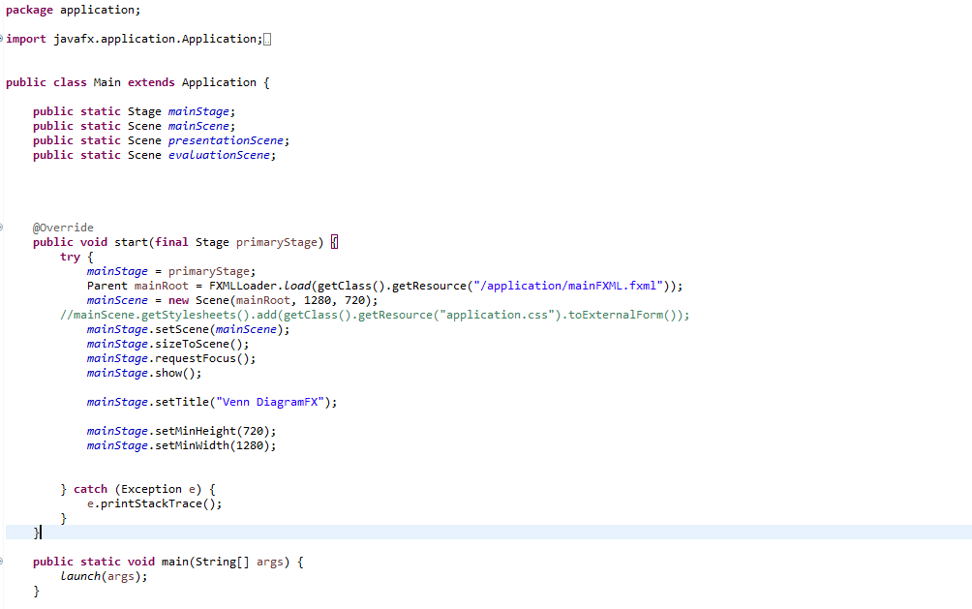

Figure 2: eclipse based on Java FX coding

**3. Common Usage Scenarios**

If a user completed a survey consisting of 8 people on which sport, they would rather play, Soccer or Basketball or no preference. The user may want to create a simple Venn diagram to display the names of the individuals who chose Soccer or Basketball and those who do not have a preference between the two.

After launching the Venn diagram application, the user may change the title located at the top of the Venn diagram to ‘Soccer v Basketball’. In order to do this the user will have to click the ‘Insert Title’ located on the top of the Venn Diagram and type ‘Soccer v Basketball’.

Now the user may want to add sub-titles (Soccer on the Left and Basketball on the right), and in order to do this, the user will have to click the ‘Insert Title’ located inside of the left circle and type ‘Soccer’, and then user will click the ‘Insert Title’ located inside of the right circle and type ‘Basketball’.

After doing all that, the user will enter the names of all the individuals that participated in the survey. In order to do this the user can double click anywhere inside or outside of the Venn diagram a label will appear that looks like this:

Insert text 1

Now the user can edit the text. A tab of the left named home allows the user to edit the text properties (Size, Font, Text Style, Text Colour) and the text itself. The user can then edit the Text at the bottom and enter the desired text. In this case, say the user wants size 14 font that is italics. In order to do this the user will select the text they want to change, and the home tab on the left will pop up, from there the user can change the size property to 14.0 under the ‘Size; tab, select Italics under the ‘Text Style’ section, and under the ‘Text’ section the user can enter:

Alex Orlando

The user can then enter the names of the rest of the people that participated in the survey in the same way the user did with the first name. In this case the user will enter:

Blake White

Chloe James

Jose Rodrigo

Harman Dhillon

Martha Silver

Jessica Grewal

Ken Lee

If the user entered all the names on one side or if they are not located where the user wants them to be, then the user can drag the names to their desired location. In this case, let’s say the first three names are for Soccer, the next three names are for basketball, and the last two are for those who do not have a preference between the two. So, Alex Orlando, Blake White and Chloe James will be on the left side of the Venn diagram under ‘Soccer’. The right side of the Venn diagram under ‘Basketball’ will have the names Jose Rodrigo, Harman Dhillon, and Jessica Grewal. In the middle of the Venn diagram where the two circles intersect, there will be two names that are Martha Silver and Ken Lee.

Since the user has wrote all the names down and drag the text into their desired placement, they can deselect ‘Click to add Text’ and ‘Drag Text’ located at the bottom of the program.

If the user does not like the colour of the Venn diagram or wants to change the size of the Venn diagram, then the user can click the design tab and change the size of either or both circles and the colour of either of both circles. In this case, say the user wants a custom green circle for the left circle ‘Soccer’ and a default orange for the right circle ‘Basketball’. Also, the user may want to change the size of both circles of the Venn diagram from the default 250 to 240.

In order to change the colour of the left circle ‘Soccer’ to a custom green (#OOff00), the user has to click the design section on the left, select ‘Left Circle’ and under the ‘Colour’ section the user can click the drop down menu, and select ‘Custom Colour …’ at the bottom. Then the user can slide the colour tool bar to the middle of the green section and drag the small circle in the square on the left all the way to the top right to get the right custom colour. If the user wants to use this colour again in the future, they can click the ‘Save’ button on the bottom right or they can click the ‘Use’ button if they only want to use it this one time.

Now to change the right circle’s colour to Blue (#334db3), the user will select ‘Right Circle’ under the design tab. Then click the drop-down menu under ‘Colour’ and select the default blue colour in the fourth row and second column. The colours should be changed of both circles now.

To change the size of the entire Venn diagram, select ‘Both Circles’ under the design tab. And the user can either use the toolbar to drag the circle to 240 or manually change the size to 240 by editing the small box beside the ‘Size’ section.

And the Venn diagram should look like this when completed:

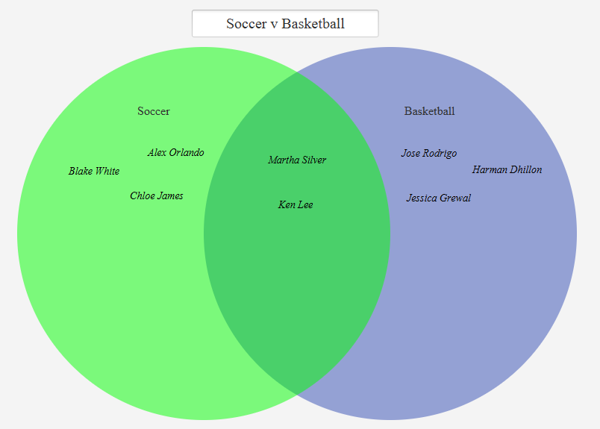

Figure 3: Venn Diagram Application Common Usage Scenario

**4. How to Get Started**

Prerequisites: Java JDK 13, JavaFX 13

*Github repository:* *https://github.com/miguel-benedict-216237364/EECS-2311-12/releases**.*

Download the latest release from the github repository, from there you can then run the jar file in the release.

If the jar file can’t be opened, open eclipse or an IDE. Ensure that JavaFX is installed properly, and your IDE uses java JDK version 13 or higher. Furthermore, you must also add the following VM arguments into the IDE

**[ --module-path "PATH_TO_JAVAFX_LIB" --add-modules=ALL-MODULE-PATH ]**

without the closed brackets and insert the file path to the javaFX library between the double quotes. From there run the Main class as a java application.

If there is any trouble downloading the application refer to the repository’s bug report section:

*https://github.com/miguel-benedict-216237364/EECS-2311-12/issues*

**5. Using the System**

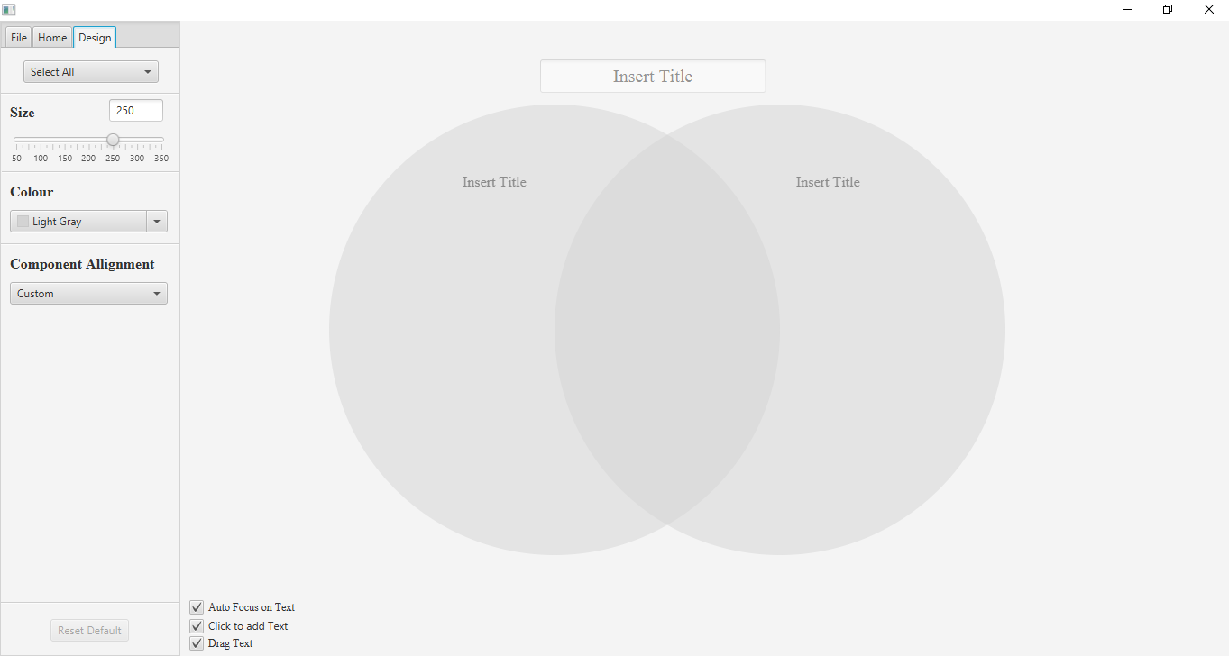Once you start the Venn Diagram Application, the program should look like this:

Figure 4: Regular View

The following sub-sections provide detailed, step-by-step instructions on how to use the various functions or features of the Venn Diagram Application.

### 5.1 ‘Insert Title’ Feature

In this area you can customize the title to your desire

*To customize the title:*

* Click on the ‘Insert title’ box to edit the title

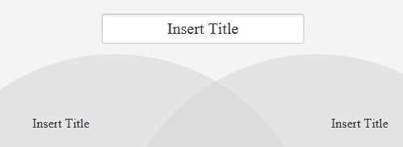

Figure 5: Venn Diagram Application ‘Insert Title’

* 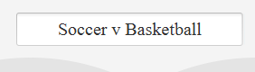Now type the desired title for your Venn Diagram

Figure 6: Venn Diagram Application new title ‘Basketball v Soccer’

*The same process is with the sub-title*

**5.2** **‘Adding entries to the Venn Diagram’ Feature**

These entries allow you to customize the text to your desire

*To add an entry to the Venn Diagram:*

* Double-click the desired location of the entry
* Upon double-clicking, a text should appear ‘Insert Text (Entry Number)’



Figure 7: New entry in the Venn Diagram

* In order to change the text, you must go under the home tab on the left and under the text section type the desired text

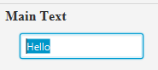



Figure 8: Adding an Entry (1) Figure 9: Adding an Entry (2)

*To disable this feature, deselect the ‘Click to add Text’ box located at the bottom of the program.*



Figure 10: ‘Click to add Text’ box

**5.3 ‘Dragging’ Feature**

*To drag a text to be placed in a different part of the Venn Diagram:*

* Simply click
* *Drag to the desired Location*

*To disable this feature, deselect the ‘Drag Text’ box located at the bottom of the program.*



Figure 11: ‘Drag Text’ box

**5.4** **‘Menu Bar’ Feature**

Menu bar contains the buttons ‘file’, ‘home’ and ‘design’ tabs that contain sections that have functions.



Figure 12: Menu Bar

#### 5.4.1 ‘File’ Tab

The ‘File’ tab contains a ‘New’, ‘Save’, ‘Load’, ‘Help’, ‘About Us’, ‘Undo’, ‘Redo’ button.

Figure 13: File tab

**5.4.1.1 ‘New’ Button**

The ‘New’ button allows the user to save the create a new Venn diagram and erases the current Venn diagram.

**5.4.1.2 ‘Save’ Button**

The ‘Save’ button allows the user to save the current Venn diagram file to their computer.

**5.4.1.3 ‘Load’ Button**

The ‘Load’ button allows the user to open a saved Venn Diagram Application file from their computer.

**5.4.1.4 ‘Help’ Button**

The ‘Help’ button allows the user to access the User manual for the Venn Diagram Application.

**5.4.1.5 ‘About Us’ Button**

The ‘About Us’ button allows the user to access the README file for the Venn Diagram Application.

**5.4.1.6 ‘Undo’ Button**

The ‘undo’ button allows the user to undo and recent changes in the diagram

**5.4.1.7 ‘Redo Button**

The ‘redo button allows the user to redo and recent changes in the diagram

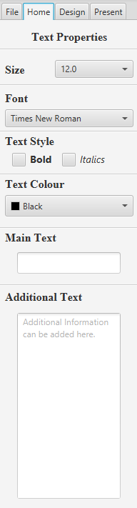

#### 5.4.2 ‘Home’ Tab

The ‘Home’ tab contains all the features and function for the text properties, which are, ‘Size’, ‘Font’, ‘Text Style’, ‘Text Colour’, and the ‘Text Editor’.

Figure 14: Home Tab

**5.4.2.1 Text ‘Size’ Feature**

The Text ‘Size’ feature allows the user to change the size of the font of each text in the Venn Diagram Application.

The font can be changed to any even number ranging from 4 to 54.

**5.4.2.2 Text ‘Font’ Feature**

The Text ‘Font’ feature allows the user to change the type of the font of each text uses in the Venn Diagram Application.

There is more than 200+ fonts available.

**5.4.2.3 ‘Text Style’ Feature**

The ‘Text Style’ feature allows the user to change the font style of each text to Bold, Italic, Both or none in the Venn Diagram Application.

**5.4.2.4 ‘Text Colour’ Feature**

The ‘Text Colour’ feature allows the user to change the colour of each text in the Venn Diagram Application.

There are a selected 120 colours to choose from, but there is a ‘Custom Colour’ feature that allows the user to create any colour they desire.

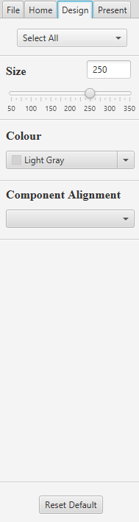**5.4.2.5 ‘Text’ Feature**

The ‘Text’ feature allows the user to edit the text to whatever the user desires in the Venn diagram application.

#### 5.4.3 ‘Design’ Tab

The ‘Design’ tab contains a ‘Size’ bar, ‘Colour’ drop down menu, and ‘Component Alignment drop down menu.

Figure 15: Design tab

**5.4.3.1 Venn Diagram ‘Size’ Feature**

The Venn Diagram ‘Size’ feature allows the user to change the size of the circles of the Venn Diagram.

In order to change the size of the left circle, the user must select ‘Left Circle’ in the drop-down menu where its written ‘Select All’ in figure 15. And once ‘Left Circle’ is selected the user can change the size of the circle using the ‘Size’ bar or by manually entering in any size ranging from 50-350.

In order to change the size of the right circle, the user must select ‘Right Circle’ in the drop-down menu where its written ‘Select All’ in figure 15. And once ‘Right Circle’ is selected the user can change the size of the circle using the ‘Size’ bar or by manually entering in any size ranging from 50-350.

**5.4.3.2 Venn Diagram ‘Colour’ Feature**

The Venn Diagram ‘Colour’ feature allows the user to change the colour of the circles of the Venn Diagram.

In order to change the colour of the left circle, the user must select ‘Left Circle’ in the drop-down menu where its written ‘Select All’ in figure 15. And once ‘Left Circle’ is selected the user can change the colour of the circle by selecting any of the 120 colours located in the drop-down menu under ‘Colour’. The user can also create a ‘Custom Colour’ by selecting ‘Custom Colour’ at the bottom of the drop-down menu under ‘Colour’.

In order to change the colour of the right circle, the user must select ‘Right Circle’ in the drop-down menu where its written ‘Select All’ in figure 15. And once ‘Right Circle’ is selected the user can change the colour of the circle by selecting any of the 120 colours located in the drop-down menu under ‘Colour’. The user can also create a ‘Custom Colour’ by selecting ‘Custom Colour’ at the bottom of the drop-down menu under ‘Colour’.

**5.4.3.3 Venn Diagram ‘Component Alignment’ Feature**

The Venn Diagram ‘Component Alignment’ feature allows the user to align the text in a circle to either be on the Left, Right or Middle.

In order to align the text in the left circle, the user must select ‘Left Circle’ in the drop-down menu where its written ‘Select All’ in figure 15. And once ‘Left Circle’ is selected the user can click ‘Left Justified’ to align the text on the left side of the circle, ‘Right Justified’ to align the text on the right side of the circle or ‘Centered’ to align the text in the middle of the circle.

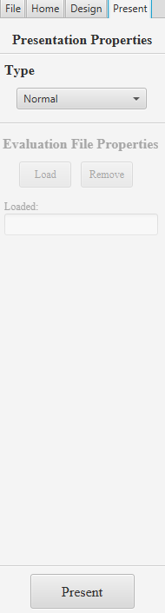In order to align the text in the right circle, the user must select ‘Right Circle’ in the drop-down menu where its written ‘Select All’ in figure 15. And once ‘Right Circle’ is selected the user can click ‘Left Justified’ to align the text on the left side of the circle, ‘Right Justified’ to align the text on the right side of the circle or ‘Centered’ to align the text in the middle of the circle.

#### 5.4.4 ‘Present’ Tab

**5.4.4.1 ‘Present Normal’ Feature**

*In this tab, we see the drop-down menu under the text ‘Type’.*

*This feature allows the user to present in two modes.*

*Normal mode is as it says, present just the diagrams.*

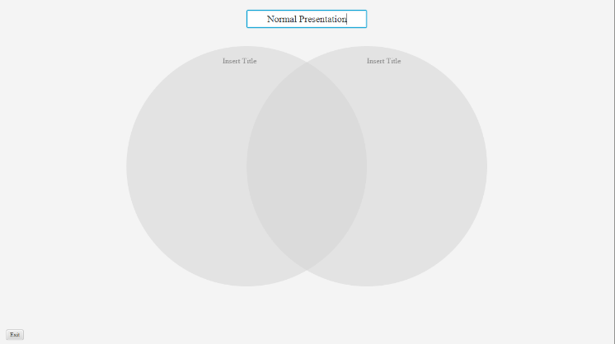

Figure 17: Normal Presentation

**5.4.4.2 ‘Present Evaluation’ Feature**

Figure 16: Present Tab

*The other option is the evaluation present. When clicked, it allows the user to load a file that was created from the application. And when clicking present, the user then has to organize the loaded texts into their respective places within the circles. To add the label, select the label and press add, to remove a label from the circles, select the label and press remove.*

*The button check, checks it the texts is currently correct or wrong. When it is wrong, the opacity is still 1.0. When it is correct, the opacity is halved, making it transparent*

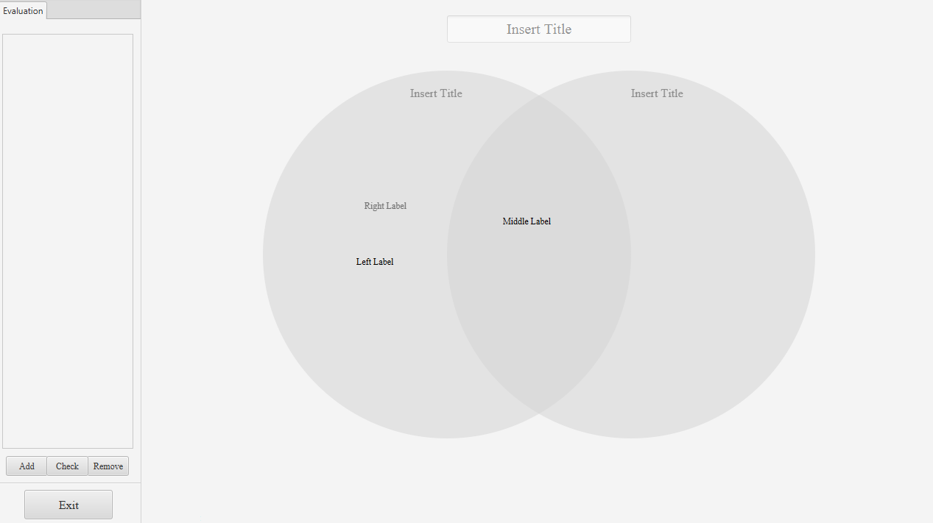

Figure 18: Presentation Evaluation Mode

**5.5 Other Features and Functions**

Additional features and functions that are shortcuts to help the user with easily functioning the program.

* Holding shift while clicking texts allow for multiple selection
* Right clicking removes all focus
* Left clicking either adds a new label or focuses on the label clicked
* CTRL + A + Backspace deletes all Text
* Backspace or Delete deletes whatever is currently focused

Appendix A: Record of Changes

| Version Number | Date | Author/Owner | Description of Change |
| --- | --- | --- | --- |
| 1.0.0 | 01/26/2020 | Group 12 | 1st Version of Product |
| 1.1.0 | 02/09/2020 | Group 12 | 1st Version of Prototype |
| 1.2.0 | 02/23/2020 | Group 12 | 2nd Version of Prototype |
| 2.0.0 | 03/08/2020 | Group 12 | Re-design and Functionality Upgrade |
| 2.0.1 | 03/22/2020 | Group 12 | Bug Fixes |
| 3.0.0 | 04/15/2020 | Group 12 | Final Version of Application |

Table 1 - Record of Changes